**Veri Tech- Web Development Internship**

**Task 02-Report**

Landing Page

**Name: Madushan Chanaka Waduwawala**

**Task Description**

Develop an engaging landing page for an event or launch of your choosing. The aim is to select a design and theme that aligns with your preferences and to create a visually compelling page that captures the audience's interest.

**Steps Taken**

* Define Your Purpose:

Clearly articulate the purpose of the plant ordering system landing page. Whether it's to facilitate easy plant purchases, provide information about different plants, or promote eco-friendly gardening practices, understanding your primary goal will guide the design and content decisions.

* Choose a Topic:

Focus on the core theme of your landing page, which is the seamless ordering system for plants. Whether it's to encourage sustainable gardening, promote specific types of plants, or offer a diverse range of greenery, make sure the content aligns with the goal of simplifying the plant ordering process.

* Research and Inspiration:

Gather inspiration by researching existing plant-related landing pages. Identify design elements, color schemes, and content strategies that resonate with the nature-centric theme. Look for features that enhance the user experience in selecting and purchasing plants.

* Target Audience:

Define your target audience for the plant ordering system. Understand the preferences and needs of plant enthusiasts, whether they are beginners looking for easy-to-care-for plants or experienced gardeners seeking rare and unique species. Tailor the content and design to appeal to their gardening interests.

* Design and Theme Selection:

Choose a design and theme that aligns with the nature hub concept. Consider using earthy tones, natural imagery, and a user-friendly layout that enhances the overall experience of browsing and ordering plants. Select a visually appealing color palette and typography that reflects the organic and green nature of the products.

**Challenges Faced**

1. Grabbing attention:

Capture your visitor's attention instantly with a captivating headline and visuals that showcase the beauty of nature and the variety of plants available. Utilize vibrant images of lush greenery, colorful blooms, and perhaps a diverse selection of potted plants to evoke a sense of tranquility and connection with nature.

1. Communicating your message clearly:

In the limited time you have, communicate the essence of your plant ordering website. Clearly convey the benefits of ordering from your hub, emphasizing aspects such as sustainable sourcing, a diverse plant catalog, and the convenience of online ordering. Craft concise and compelling copy that highlights the unique value visitors gain from exploring and purchasing from your nature-inspired collection.

1. Keeping them engaged:

Maintain visitor interest by designing a visually appealing and user-friendly interface. Incorporate high-quality images of individual plants, offer plant care tips, and use infographics to showcase the ease of the ordering process. Break up textual content with visuals to create a seamless and engaging scrolling experience, allowing users to explore the green world you offer.

1. Prompting action:

Guide visitors toward the desired action, whether it's creating an account, exploring the plant catalog, or making a purchase. Design a clear and compelling call-to-action (CTA) button that stands out on the page, encouraging users to take the next step. Use persuasive language that aligns with the nature theme, such as "Grow Your Green Haven" or "Start Your Sustainable Garden Now."

Challenges Specific to Design and Theme:

For the nature-focused theme, ensure that the visuals, color palette, and overall design evoke the serenity and natural beauty associated with plants. Use earthy tones, such as greens and browns, and integrate natural textures. Align the design with the sustainable aspect by incorporating eco-friendly symbols or badges to convey the commitment to environmentally conscious practices. Additionally, personalize the content to resonate with your target audience's love for nature and gardening, creating a sense of community within your plant ordering hub.

**Solutions Implemented**

* Online ordering: Nature Hub could have an online ordering system where customers can browse and purchase plants from the comfort of their own homes. This would be convenient for customers who don't have the time or ability to visit a physical store.
* Delivery: Nature Hub could offer delivery services so that customers don't have to worry about transporting their plants themselves. This would be especially helpful for customers who live in apartments or who don't have a vehicle.
* Plant subscriptions: Nature Hub could offer plant subscriptions where customers receive a new plant each month. This would be a great option for people who want to add to their plant collection but don't know what to buy.
* Local partnerships: Nature Hub could partner with local businesses, such as coffee shops or restaurants, to sell their plants. This would give Nature Hub access to a wider customer base and would also help to promote the businesses they partner with.
* Community events: Nature Hub could host community events, such as plant workshops or garden tours. This would be a great way to get people interested in plants and to build relationships with potential customers.

**Learnings**

* Gained a deeper understanding of landing pages web design principles.
* Enhanced skills in implementing creative elements within a specified design framework.

**Project Update**

The website has a nature theme, which is evident from the use of the green color scheme, the leaf logo, and the images of plants. The text-heavy design with minimal graphics gives the website a more informative feel.

Overall, the website is clean and easy to navigate. The homepage has a clear hierarchy of information, with the most important information at the top of the page. The navigation bar is simple and easy to use.

**Figure 1**

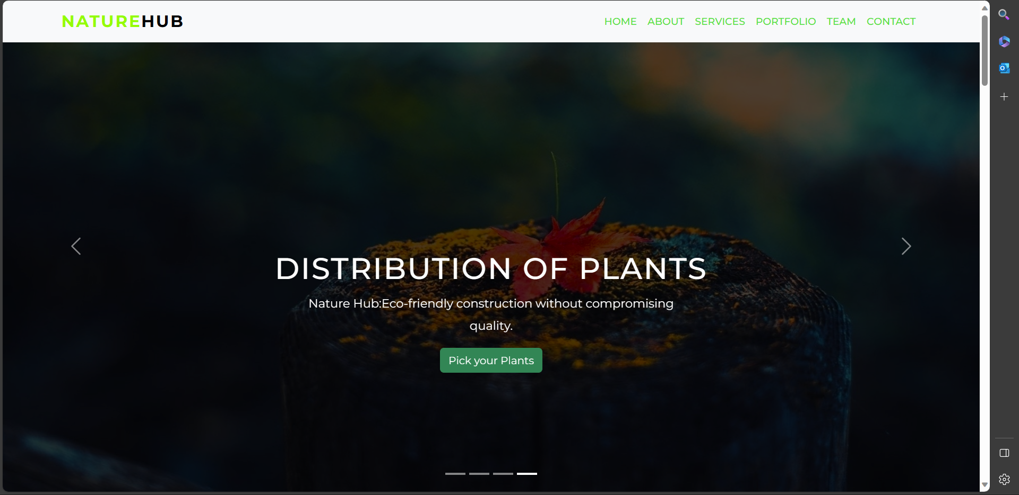

**Figure 2-About page**

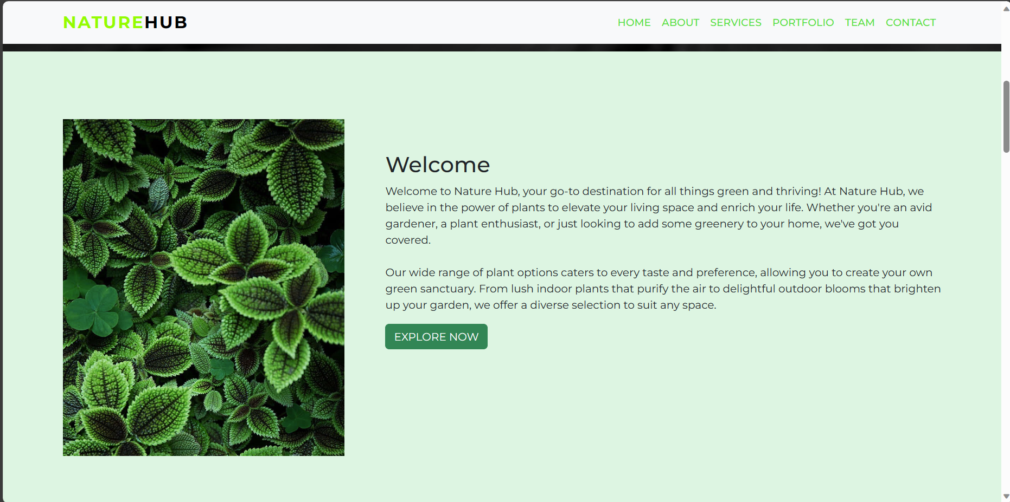

**Figure 3-Services page**

**Figure 4-plants page**

**Figure 5- Our Team page**

**Figure 6- contact us page**

